Database Extractor Pro

Contents

Description Page

User Form 2

Log Files 4

User Guide 5

Enhanced User Guide 6

SQL Guide
Syntax 7
Examples 8

Special Features
Database Extractor Pro User Interface

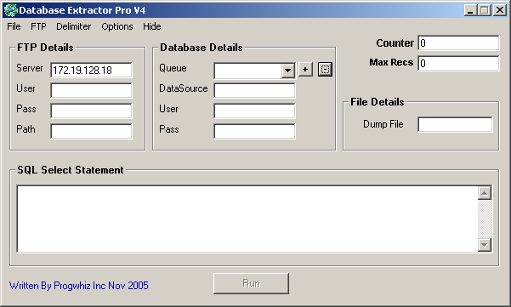
Fig I
I
A
B
C
D
E
F
G
H
J

A – FTP Details
B – Activate / Deactivate FTP
C – Set the type of flat file produced (Fixed length, Comma or Tab delimited)
D—Database ODBC Setting
E – Immediate Run of the Application
F – Select Statement
G – Name of the flat file to be produced
H – Maximum No of records to return (Zero if no limit)
I – Counter to show number of records returned
J – Create several extract processes using same or different SQL on same or different database instances

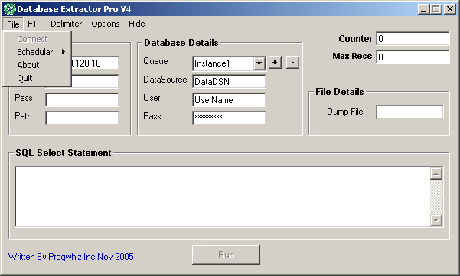

J

J – Connect to the Database pointed by the ODBC DataSource Name entered

Auditing Features & Log Files

File Name Description
FILEUPL.LOG Records the Date, Time, Name of file sent and the size in bytes as well as if the transfer was a FAIL or PASS.

VALUES.LOG Records the last settings used for the Ftp Login and the Database Login. The password is encrypted in this file for security measures

ERR_UPLOAD.LOG Records the Date & Time the FTP could not connect to the FTP server or Network to initiate an Upload.

REPORT_LOG.TXT Records the Start/Stop Date & Time a task ran
User Guide

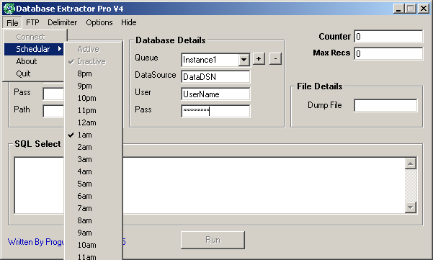

Fig II
1
2
5
3
4
6

Step 1 (Mandatory)
Enter Settings for Database file as shown in (6). This done by clicking + then entering the
DSN/User/Pass info.

Step2 (Optional)
Enter FTP settings

Step3
Enter the SQL statement desired as shown in (4). The syntax of the SQL statement is same logic as
standard SQL with a simple amendment as explained in page 6

Step4
Set the name of the dump file as shown in (5)

Step5
Select Connect as shown in (1) to verify Connectivity and SQL syntax

Step6
Run the query and populate the dump file. This can be initiated by one of two(2) methods

- Manually – Shown in (3)

- Automatically Scheduled – Shown in (2)
Enhanced User Guide

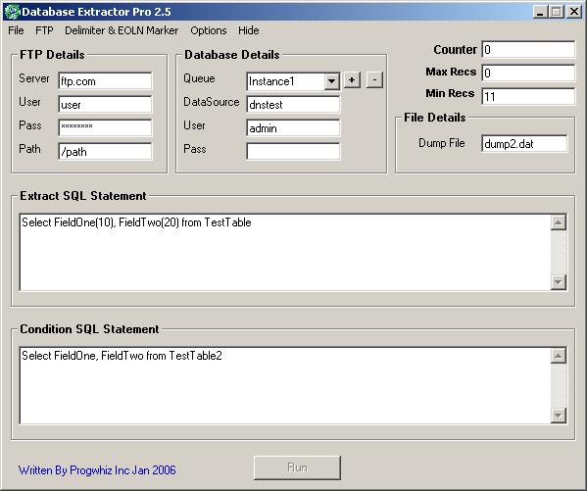

The Database Extractor Pro extracts data once the following conditions are satisfied.

- Condition SQL statement that must return a Record Count greater than 0 or the Statement is left blank
- Min Recs must be greater than or equal to the value entered or Value entered is Zero(0)

SQL Guide

The following will show an example of standard SQL and the syntax of the SQL the application will interpret correctly. The rational for the syntax variation is to facilitate proper file layout of the data to facilitate easy importation into any Database / Spreadsheet / Word Processor.

Syntax

Standard SQL

Select FirstName, LastName from Employee

Application SQL

Select FirstName(20), LastName(20) from employee

* Where FirstName, LastName are pseudo examples of field names in the table ‘employee’ chosen

As seen in the above example the value in parenthesis indicates the length of the field. Not only does this ensure the value in the field is less than or equal to the length value depicted, it also fills with spaces to ensure the field width is fixed.

N.B “Select *” is NOT Valid syntax. Field names must be entered explicitly

Examples

Application SQL

Correct

Select FirstName(20), LastName(20) from employee

InCorrect

Select Trim(FirstName(20)), LastName(20) from employee

Correct

Select FirstName(20), LastName(20) from employee where FirstName = ‘Paul’

Correct

Select FirstName(20), LastName(20) from employee where Trim(FirstName) = “Paul”

Correct(MS SQL)

Select FirstName(20), LastName(20) from employee where mid(Trim(FirstName),1,1) = “P”

Correct(Oracle SQL)

Select FirstName(20), LastName(20) from employee where substr(Trim(FirstName),1,1) = “P”

Special Features

- Manual Run

- Automated Scheduled Run (Daily)

- Simple SQL semantics

- FTP uploading capability to port the exported file to any platform or location

- Varied file layouts supported to ensure easy importation into another platform

- Logging of all events

- Ability to set to retrieve only sample recordsets

- Encryption for all passwords (Database & FTP logins)

- Friendly prompts to guide user if an error in setting up occurred

Features (Pro)

- Strict user control Enable/Disable of user buttons where applicable

- Multiple database instances saved to facilitate extracts from various database/tables using multiple SQL Select scripts

- Ability to Date/Time stamp ‘dump’ files

- Auto Error correction capability in the event field data is corrupt or actual field names are incorrect

- Additional end of line characters Menu options

- New support for MDAC if Database is not connecting as shown below in Fig A

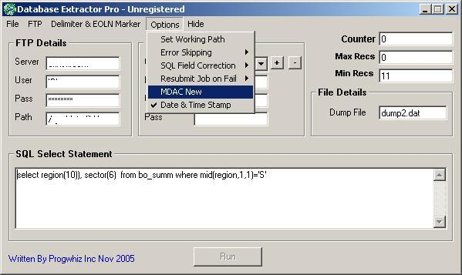

Special Note:

Installing on Win2k/2k3 Server OS or WinXP64 may require installing MDAC 2.5x

Latest Features (23rd May 2007)

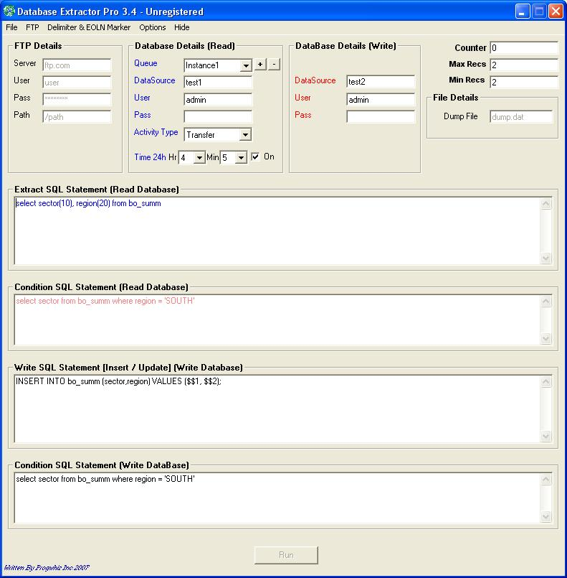

Features:
- Ability to set Minimum records to be reached or file will not be produced
- Ability to set a select statement with a condition that must produce at least one record for the Extract SQL to produce results (Optional)
- Ability to set a schedule time for each DataBase schema entered
- Ability to either:
  - Produce an extract File
  - Transfer the contents of the extract to another Database

N.B. The Insert & Update syntax must conform for the standards of SQL syntax. The only exception is the ability to enter Variables that are in relative harmony with the Extract SQL statement in the first Text Box

