Time Tracker Application

Manual

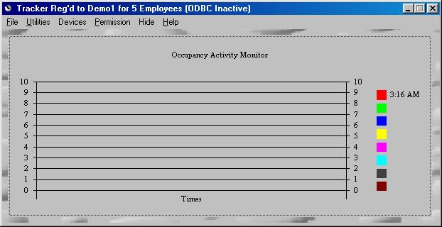
TimeTracker

ReadMe Documentation Ver 3.1b

Contents Page

Over View 3

Installation

General Launching 4, 5
Port Configuration 6
Barcode Manager 7
User Administrator 8
Customer Manager 9
Supplier Manager 10
Peripheral Manager 11
Multi–Curreny Manager 12

User Guide 13

Settings 14, 15

Export 17 -18

Reports 19 - 27

Functionality 28

Data Specifications 29-33

ODBC Connectivity 34-36

Menu Over View 37

Special Options 38

Multi Client Over View 39

OverView

Time Tracker is an application which acts as an interface between payroll ,security and point of sale systems and scan readers. It captures information about employees and items which are logged each time a barcode is read or swiped. The specifics of its use and how it interfaces with each application and hardware is detailed in this document. The data accumulated by Time Tracker is recorded on Microsoft Database as well as a Text delimited file. Both are updated simultaneously and hence easily imported by all database applications. The system is pre-configured with Microsoft Jet database files for immediate use. If ODBC connectivity is desired please consult page 16 for the specifics.

The attractive features of Time Tracker are :

- Ease of Use

- Up and running within minutes

- Highly Fault Tolerant

- Powerful Report Generator in one Form

- Ensures integrity of data accumulated

- Charts/Reports for easy interpretation

- Checksum for all data written to prevent manual editing outside the application

- Encrypted Data

Installation

Hardware

The hardware comprises of these key components:

Barcode Reader
Wand Scanner
Slot Badge Scanner
Power Base

Cabling (RS-232, RS-422)

Serial Com Port(s)

The following is a diagrammatic representation of a typical installation.
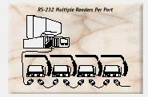
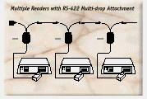
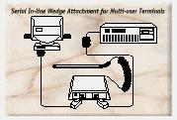
Fig A Fig B Fig C

A typical installation is shown in Fig A. In that diagram the serial Base is connected to the back of the PC to a serial port via a serial cable, in turn a barcode read (Wand, Badge or Radar Scanner) is connected to the front of the serial decoder.

In Fig B a diagrammatic representation of a daisy chaining of serial decoders to facilitate several barcode readers on one serial port.

In Fig C we see another form of daisy chain , but instead of using the R-232 interface it uses the R –422 interface. The difference between these two types of interfaces is that in the R-232 the cabling can be only up to 100ft from the serial base, however with the R-422 the cabling can be up to 1000ft.

Software

System Requirements: Windows 9x Operating System, 16MB Ram, 20MB HDD Space.

The setup and configuration can be categorised in three (3) easy phases..

- Install the software via the setup wizard on the CD

- Configuration of the Communication Port

- Registering of all Employees/Items into the System

Phase 1

Insert the CD into the CD-Drive. Double Click on the Setup file, follow the prompts. The suggested defaults should suffice and suite most if not all computer configurations.

Phase 2

Launch the application by clicking on Windows START button and navigating through Program Files till you locate the TimeTracker group. Upon launching click the File Menu as shown below:

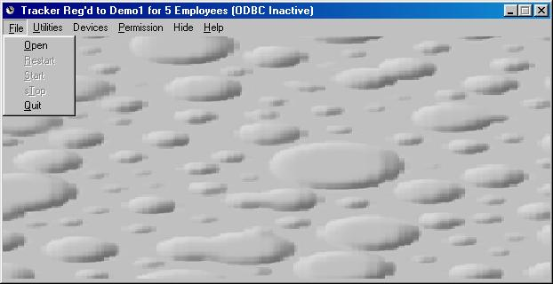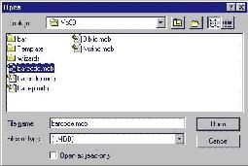

Fig 1 Fig 2

As shown above upon clicking on the Open sub menu option a dialog box appears. Double Click on the Barcode.mdb file (for ODBC version no dialog box or files are shown). Now Click the Utility Menu and select the Port Configuration sub menu as shown below in fig 3.

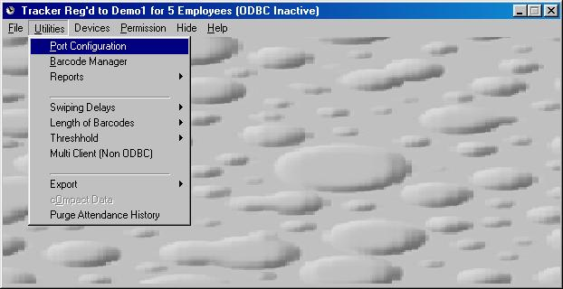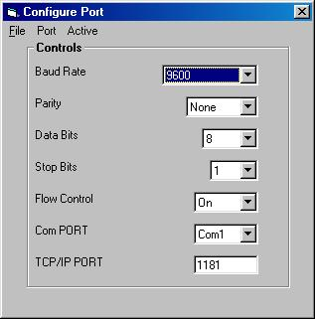

Fig 3 Fig 4

Fig 4 is now displayed and from this form the user can set the COM Port to the desired settings. The default settings should conform once again to most systems and highly unlikely any modifications need be made. The options which are available to the user are as follows:

- Com Port Number (Com1,Com2,Com3 or Com4)
- Baud Rate (9600,19200,… 56k etc)
- Parity (None, Odd, Even)
- Data Bits (4,5,6,7,8)
- Stop Bits (1, 1.5, 2)

When the settings have been changed you can save the new configuration using the File – Save sub Menu. This will record the new settings for your current session as well as any future Run until the configuration is altered and saved at a later date.

Phase 3

This step involves the registering of all Employees/Items that you wish the system to recognise. Please note that only barcodes registered in this step will be recognised by the system. Please Click on the Utility Menu and select the Barcode Manager sub menu. Fig 5 is displayed as shown below.

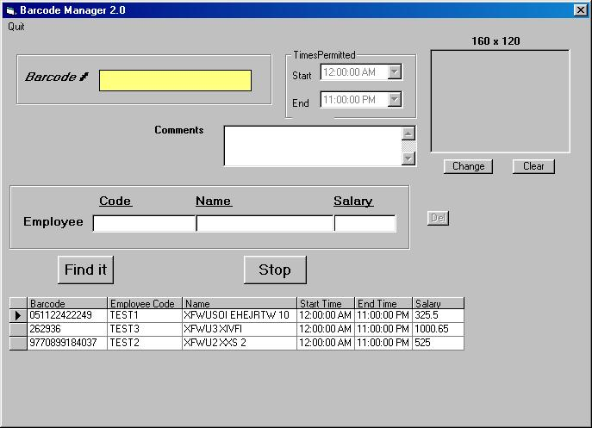
Fig 5
When a barcode is read it is displayed in the Yellow box. The box’s Code and Name will now permit entry/modification. The reason for stating modification is that if a barcode is read that was previously defined by the user to the system. The code and name fields will be automatically populated. Hence removing the possibility of duplicate entries. New entries as well as modifications can be cancelled or accepted using the Ignore and Accept buttons respectively.
It is worth indicating that a start and end time is also entered to denote what hours and employee may or may not be allowed at the work place. The default Start and End times permit 24hr access.
When all entries have been processed you may choose the Quit menu option to leave this configuration screen,

User Administrator

The following form depicts the screens to manager User Accounts on the system. Figs 5a & 5b

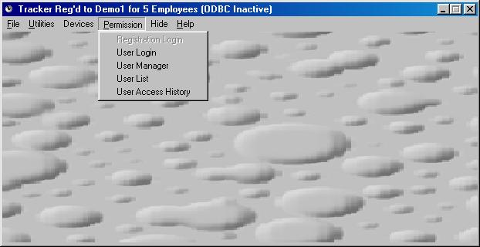
Fig 5a

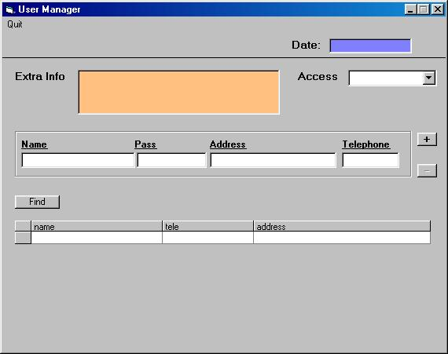

Fig 5b

Customer Manager

The following form depicts the screens to manager Customer Accounts on the system. Figs 5c & 5d

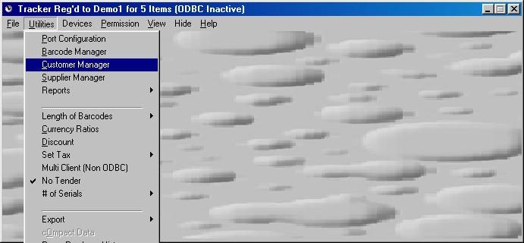
Fig 5c

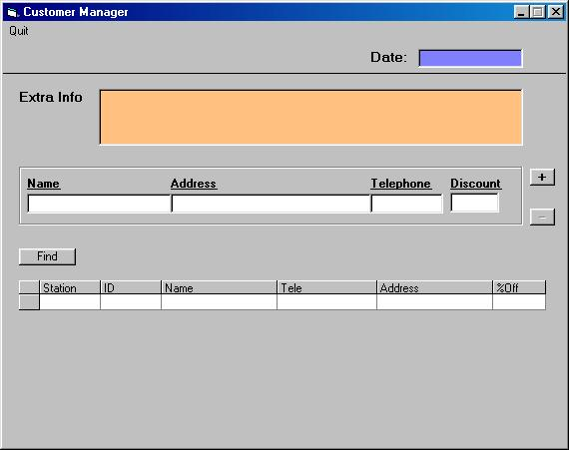
Fig 5d
Supplier Manager

The following form depicts the screens to manager Supplier Accounts on the system. Figs 5e & 5f

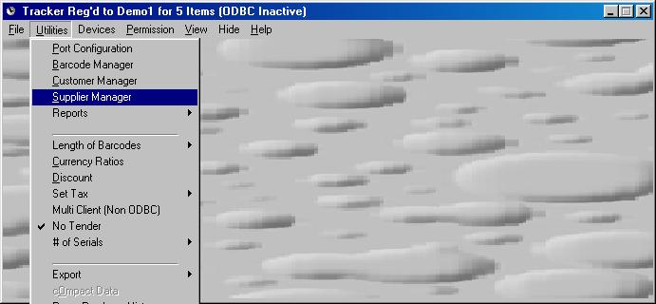

Fig 5e

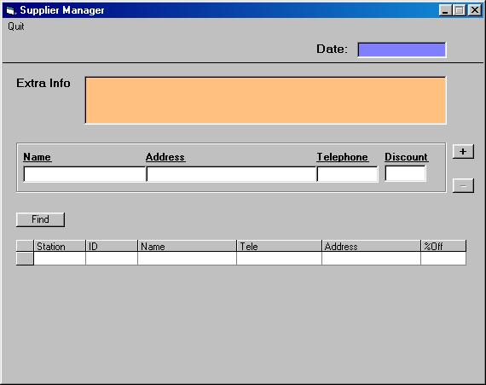

Fig 5f

Peripheral Manager

The following form depicts the screens to manage External Peripherals on the system.

- Cash Drawers
- Electronic Displays
- Electronic Locks/Doors

As shown below in Figs 5g & 5h

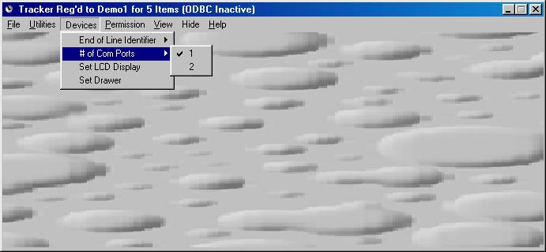

Fig 5g

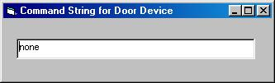

Fig 5h

Multi–Curreny Manager

The following form depicts the screens to manage Currency Rates on the system. As shown in Figs 5i & 5j

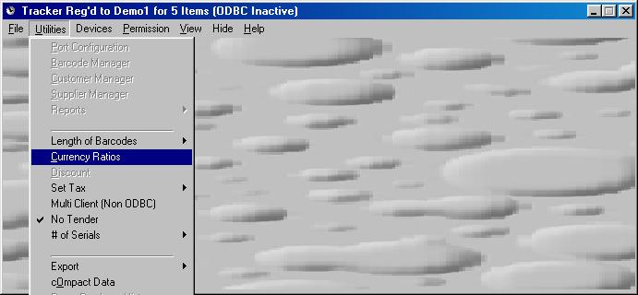

Fig 5i

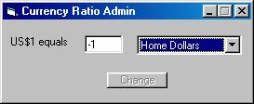

Fig 5j

User Guide

Quick Start

There are Two (2) easy steps to initiate the Time Tracker application as depicted below(Employee Attendance Screens shown):

- Open the database as shown in Fig 1 & 2.
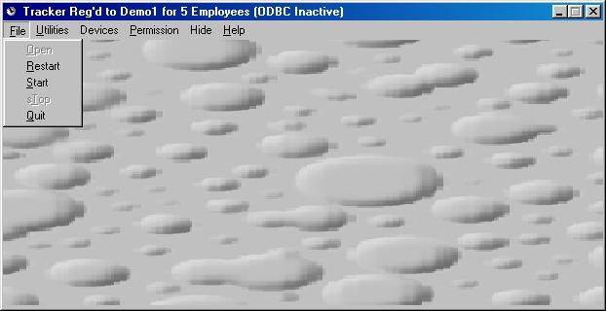
Fig 7 Fig 8

- Click on File and select Start as shown below in Fig 7 & 8

Maintenance

There are two maintenance screens in the Time Tracker application one is the Purge Utility to remove old
Data from the system, either by Year or by Month in a particular year, the screen is shown below in Fig 9.
It is not to be used to rollback records it is merely to purge old records and optimize the database.
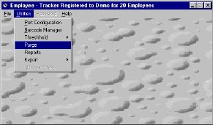
The User must choose a Year and the Month drop down list is optional, meaning that in order to purge a month the user must specify a year but not visa-versa.
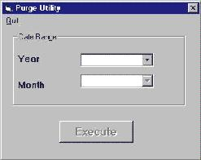

Fig 9 Fig 10

Settings

General

The following depicts how the barcodes are to be interpreted by the number of digits to expect. By default the system assume variable length barcodes. In addition to this if depending on the peculiarities of the scanner/reading device a fixed length barcode can also be set to ensure proper capturing of the barcodes. This is shown below in fig 10a.

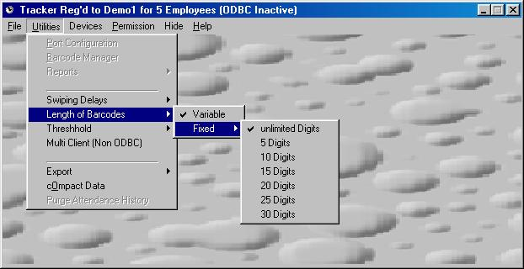
10a

Time & Attendence
The Time Tracker application permits the user to define the Normal Working hours as well as the Grace Period (Fig 11a) with which the user can log themselves out of the system before the computer system logs them out automatically. These features are located in the Threshhold Sub Menu located under the Utility Menu option as shown below in Fig 11.

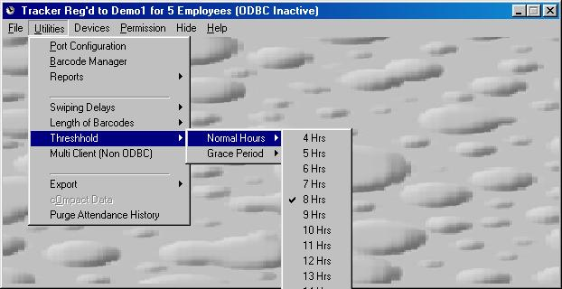 Fig 11

These settings are saved and become active for the current running session of the application and are active for every subsequent session until the settings are changed.

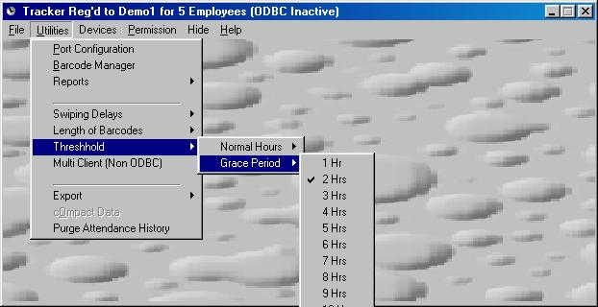 Fig 11a

Point of Sale
The following is the settings to choose which apply to a point of sale application. Primarily Purchase or Value Add Tax as shown below in fig 11b.

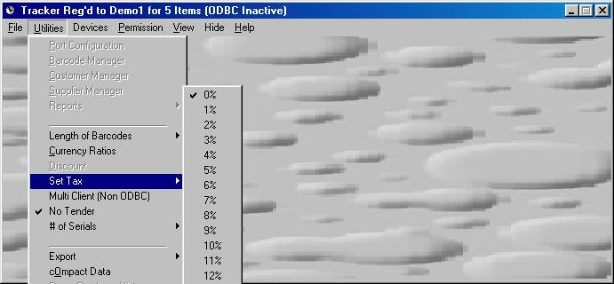

Fig 11b

Export
The export module is a sub menu off of the Utilities Menu option as shown in fig 12. There are two key options, one is to Save to a Text delimited file and the other to flush the contents. The flush option is to clear write all of the contents in the file buffer to the text file. The File option pulls up another form as shown in fig 13

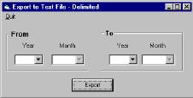
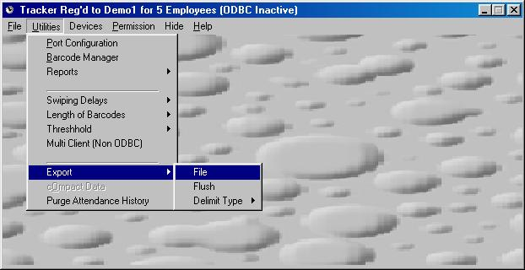

Fig 12 Fig 13

Shown below in Fig 13 is the exported delimited text file named Export.Dat. The columns exported are as follows:
- Code – Employee / Item Code
- Name – Employee / Item Name
- Timein – Time Checked in
- Timeout -- Time Checked out
- Datetime -- Date Checked In
- Dateret --Date Checked Out
- Timdif -- Total Time in Hours(only for Employee & Rental Package)
- Typeset -- If Checked out by barcode (B) or by System (C)
- Transno -- Transaction Number (For Item / Rental Systems only)
- Transin -- Item Number for a particular transaction (For Item / Rental Systems)
- Person – Person Name (Rental & Point of Sale Only)
- Address – Person Address (Rental & Point of Sale Only)
- Amount – Only applicable to Rental & Point of Sale, default is 1 for Employee Package
- Value –
- Denotes Salary for Employee Package
- Denotes Subtotal of Rental/Sale without discount
- Station ID – Denotes the number assigned to each PC the software is installed
- Discount – Denotes the discount , only for point of sale packages
- Tax – Purchase tax appears only for point of sale packages
To assure integrity if this export file is imported onto a remote RDBMS the primary key is a composite of
Station ID, Transno, Transin, Datetime, Timein, Code (or Name).
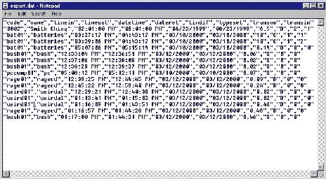

Fig 13

Reports

There are three versions of the Time Tracker application. They are as follows:

- Time & Attendance – Payroll & Security Systems

- Item Sales – Point of Sale Systems

- Item Rentals

- Additional Reports

Any criteria not specified or populated in the List Down Boxes will be omitted from the Query. For example if the Year list down box is not populated then all the years are searched. This holds for every list down box on each respective report module.

Time and Attendance
The Key Fields in this Reporting module are shown in fig 15 and the report is displayed as shown in fig 16

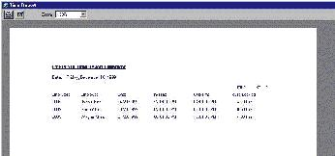
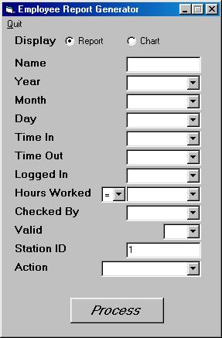

Fig 15 Fig 16

Item Sale

The Key Fields in this Reporting module are shown in fig 17 and the report is displayed as shown in fig 18. Each Cash Register will contain the name register hence not showing the management menu options. Also each client will have a station ID to keep track of which PC or terminal the transaction was processed.

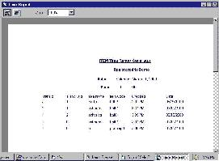
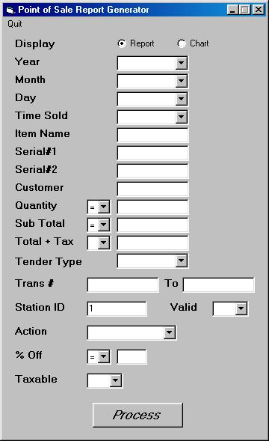

Fig 17 Fig 18

Item Rentals

The Key Fields in this Reporting module are shown in fig 19 and the report is displayed as shown in fig20
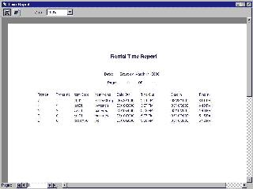
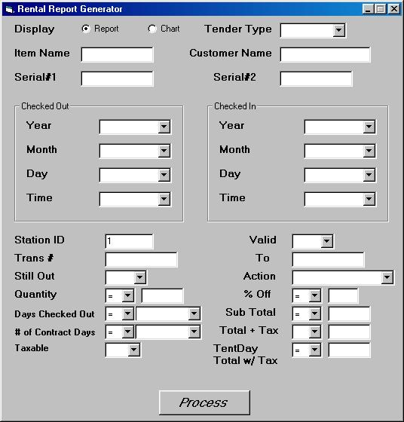

Fig 20

Fig 19

Stock History Rentals

Stock History Report form shown below in Figs 20a, 20b & 20c

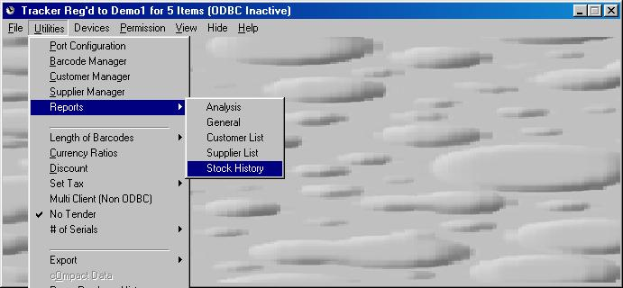
Fig 20a

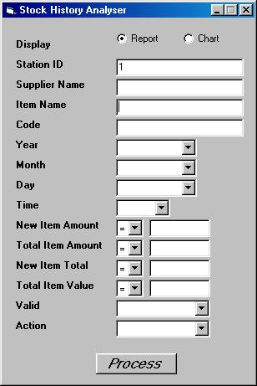
Fig 20b
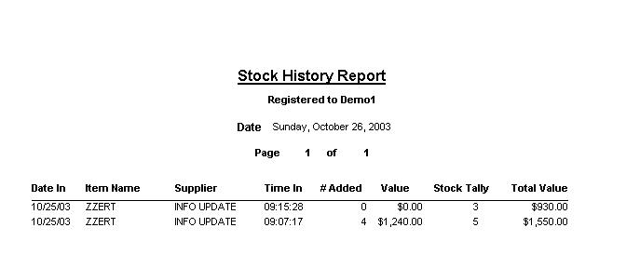
Fig 20c

Customer List

Customer List Report form shown below in Figs 20d , 20e & 20f

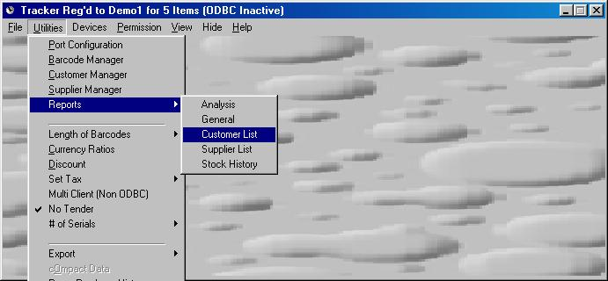
Fig 20d

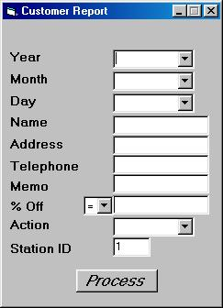
Fig 20e
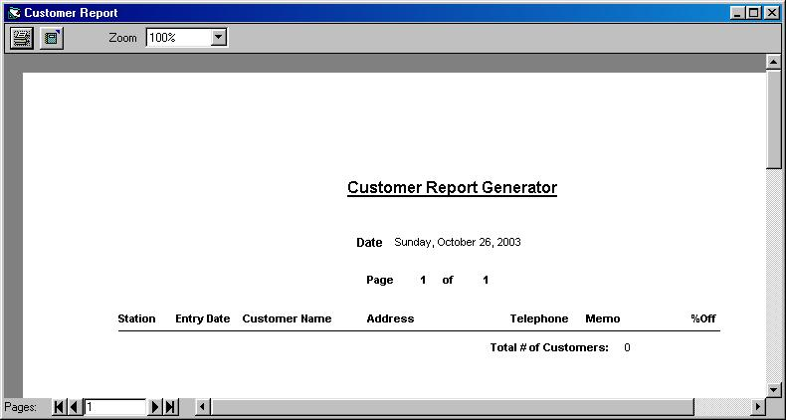
Fig 20f

Supplier List

Supplier List Report form shown below in Figs 20g , 20h & 20i

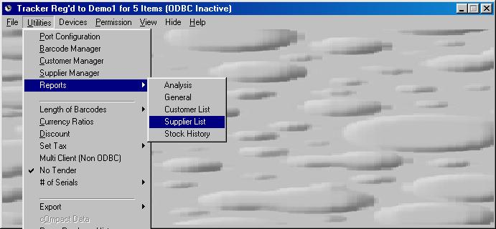
Fig 20g

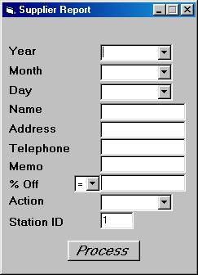
Fig 20h

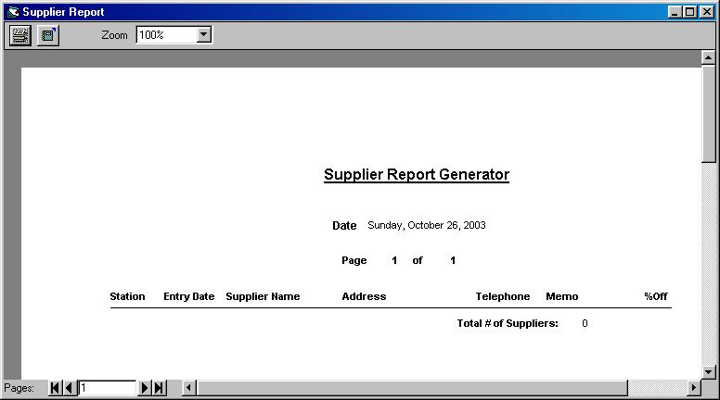
Fig 20i

User List

User List Report form shown below in Figs 20j , 20k & 20l

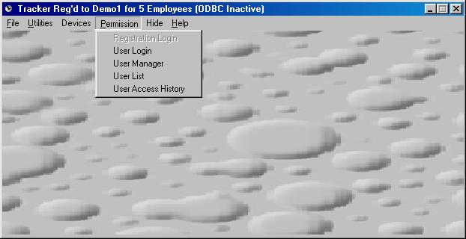
Fig 20j

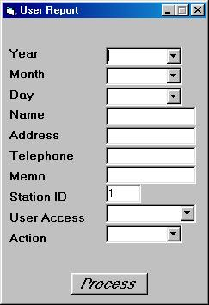
Fig 20k

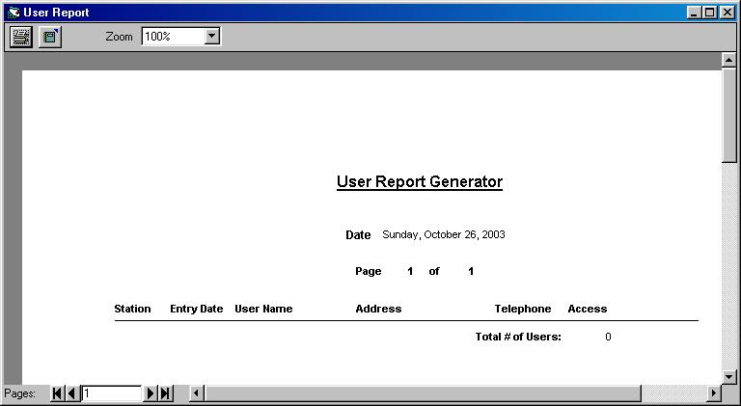
Fig 20l

User Access History

User Access History Report form shown below in Figs 20m , 20n & 20o

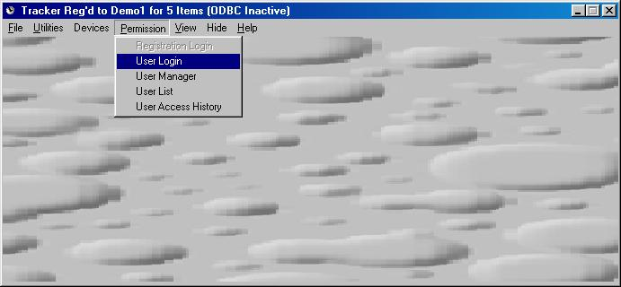
Fig 20m

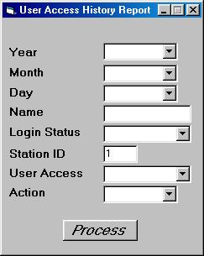
Fig 20n

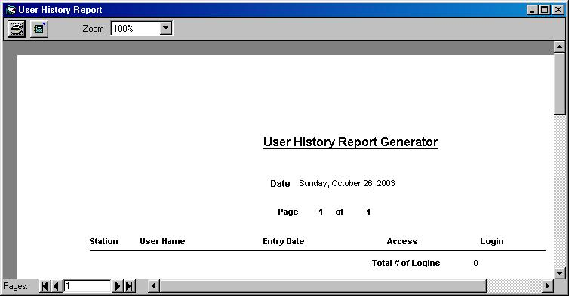
Fig 20o

Functionality

- Open Database to facilitate easy Integration with an existing Package

- Auto Logout of Employees when Threshold time is met or surpassed
Thereby ensuring all data has a start and end time to compute the hours worked

- Activity Chart Display to examine status at a glance

- Report generator to compliment existing Payroll or Inventory System

- Stock / Employee Analysis

- Time difference is computed and stored as a separate column Value

- Key Fields that any Payroll will be concerned with are as follows:

- Employee Code
- Employee Name
- Hours Attended (per day/week/month)
- Start and End Times (on time attendance assessment reports)

- Encrypted Names in System Database

- Security to ensure no tampering with data. Ability to flag records which failed validation checks

- Time restrictions to permit Employees / Items to be checked In / Out

- Permits multiple barcode readers and buffers simultaneous Checked In/Out’s

- Can Facilitate a Payroll, Point of Sale, Inventory and or Rental Package

- Password restriction to permit Authorised access Only! to Data management forms and reports

Specifications

The primary Microsoft Databases are Barcode.mdb and Barcoder.mdb. Their tabular layouts are shown in figures 21 and 22 respectively.

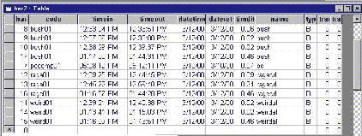
Fig 21

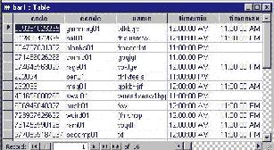
Fig 22

Time Tracker for Table Structure and the Columns that are active for the respective application.

 | Employees | Point of Sale | Rental
Code | Yes | Yes | Yes
TimeIn | Yes | Yes | Yes
TimeOut | Yes |  | Yes
DateTime | Yes | Yes | Yes
DateRet | Yes |  | Yes
TimeDif | Yes |  | Yes
Name | Yes | Yes | Yes
Typeset | Yes | Yes | Yes
TransNo |  | Yes | Yes
TransInc |  | Yes | Yes
Amount |  | Yes | Yes
Value | Yes | Yes | Yes
Person |  | Yes | Yes
Address |  | Yes | Yes
Station | Yes | Yes | Yes

Text Files – Used to interface with Third Party Payroll, POS and Rental Applications

Bar.Dat - Used to Interface with other POS and Rental Applications only. This file
is written by TimeTracker and Read by the respective POS or Rental Application. The
value written is the Code supplied by the company which correlates back to the barcode
number.

Export.Dat – Can be used by Payroll, POS and Rental Applications. It is a text
delimited file which affords easy importation of data accumulated by
TimeTracker.

Fraud.Dat – This logs every occurrence of duplicate barcode/magstrip detection. Only
applicable to the Time & Attendance module

Chartf.Dat – This sets the time delay between updating the attendance chart display.
Only applicable to the Time & Attendance module

User.Dat – This stores the variables for DataBase Name, User Name and Password.
The form that permits the user to change these values is the submenu
option ‘Set User/Pass’. This option is only available if the registration key
is for ODBC type access.
Table Definitions for use with ODBC

Table BAR2

Barkey | Char
Code | Char Not Null
Timein | Char
Timeout | Char
Datetime | Date
Dateret | Date
Timdif | Number
Name | Char Not Null
Typeset | Char
Transno | Number
Transin | Number
Amount | Number Not Null
Value | Currency Not Null
Person | Char
Address | Char
Station | Number
Chk | Number Not Null
Discount | Single
Tax | Currency
Value2 | Currency

Table BAR1

Code | Char
Ecode | Char
Name | Char
Timemin | Char
Timemax | Char
Amount | Number
Value | Currency
Station | Number
Totval | Currency
Chk | Number
Discount | Single
Datetime | Date
Descrip | Char

Table BAR1_HIST
Code | Char
Name | Char
Timein | Char
AddAmount | Number
NewAmount | Number
ValueAdd | Currency
ValueNew | Currency
Station | Number
Chk | Number
Datetime | Date

Table BAR1_CUST
ID | Char
Name | Char
Address | Char
Telephone | Char
Extra | Char
Station | Number
Chk | Number
Cust_off | Number
Joindate | Date

Table BAR1_SUP
ID | Char
Name | Char
Address | Char
Telephone | Char
Extra | Char
Station | Number
Chk | Number
Cust_off | Number
Joindate | Date

Table BAR1_USR
ID | Char
Name | Char
Address | Char
Telephone | Char
Extra | Char
Station | Number
Chk | Number
Typer | Char
Pass | Char
Joindate | Date

Table BAR1_USR_HIST
ID | Char
Name | Char
Login_Status | Char
Station | Number
Chk | Number
Typer | Char
Joindate | Date
ODBC Default Settings

Default Names to be created and configured for ODBC to work are:
DSN barcoder

Database Name bars
User Name barcode1
Password tester

It is noteworthy to mention that although the application supports ODBC there may be some connectivity issues dependent on the SQL backend and the drivers installed on the PC running the application. Also the DSN name must be setup properly by the installer/database manager.
N.B. The appropriate ODBC drivers must be preinstalled on the PC which the application will be configured, AND DSN name associated with the database must be BARCODER. All other names noted at the top of this page apart from the DSN is configurable by the user/admin.

The ODBC has been tested on all SQL compliant DataBase Engines

The default key provided assumes Non ODBC, for ODBC modules to become active you must request this when registering your software.

Below Fig A shows the option to select the Standard of SQL your database is in sync. Login to the database using the form shown in Fig B which is easily accessed via the main menu system.

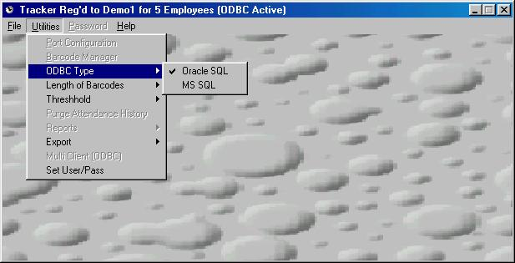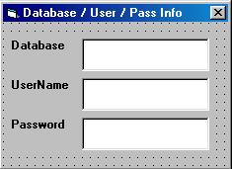
Fig A Fig B

N.B. Please ensure to run the TABLE_CREATE.SQL provided on the website at
http://www.progwhiz.com/files/table_create.sql

This will create the table structures to accommodate the application. The script is written in standard SQL. It may need to be modified slightly for MS SQL type database engines
How to Setup ODBC on your WorkStation

- Launch CONTROL PANEL
- Launch ODBC Configuration Tool
- Create DSN

1) Launch CONTROL PANEL
Goto Start / Settings → Control Panel

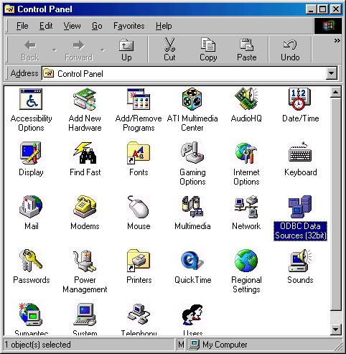

2) Launch ODBC Configuration Tool
Double click on the ODBC Icon
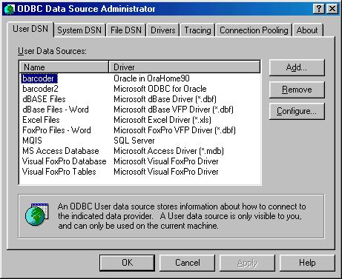

How to Setup ODBC on your WorkStation (Cont’d)

Create DSN

Click on ADD tab , then select the ODBC driver appropriate to the Database you wish to connect and press Finish.

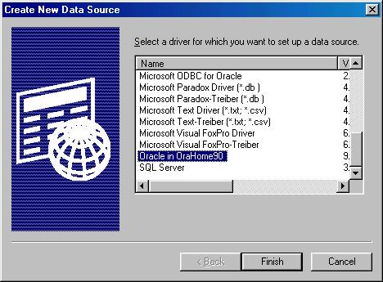
Enter the following details such as
Data Source Name (Must Be BARCODER)
Description (Anything)
TNS Service Name (Database Name or IP)
User ID (any Login Name on the database that has access to the tables created by the SQL script provided)

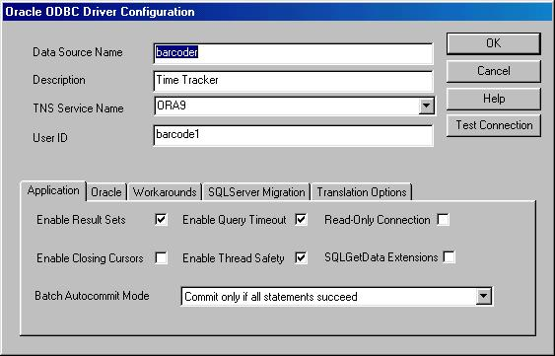
Menu OverView

- Menu Options
File
- Open
- Select Database to load.

- Start
- Start the Port Listeners to activate the barcode readers.

- Restart (Employee Module only)
- Logout all employees and restart a new.

Utilities
- Port Configuration
- Configure the ComPort settings to match the configuration of the barcode reader.

- Barcode Manager
- Add all the Employees (Items in inventory) and map the barcode# to the respect
Employee name (Item Name).

N.B. Only persons or items registered here will be recognised by the system.

- Set Overtime ThreshHold (Employee version Only)
- Set the maximum number of hours an employee is expected to be logged into the
System before it logs them out automatically.

- Set the Grace Period with which the user can log out of the system manually

N.B. The system flags the difference between a barcode swiped logout and a computer logout.

- Purge
- To remove records from the system on a month/year basis.

- Reports
- Reports to display employees or Items logged in/out or sold respectively.

- Compact Data
- To compact the System Data to Optimise performance over time.

Password
- Password to enable Purge and barcode Manager menu options
Help
- Context sensitive Help

Special Options(Point of Sales Module)

The following menu option is available to toggle the Application from a billiable system to a non billable system. Essentially toggling between an

- Inter-Department Inventory system

- Sales Inventory System

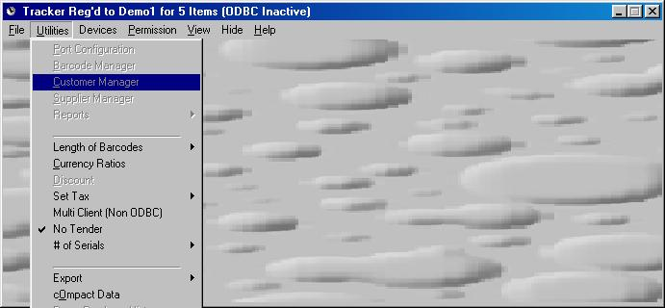

When the “No Tender’ option is Ticked it means it is meant for Inter-Dept activity or dispenses of stocks without requiring money tender
Multi Client

The Default menu settings caters for a stand alone application (Single User). However checking the ‘Multi Client’ Sub Menu option found under the Utilities Menu option, enables multi station support. This activates extra procedures to ensure database integrity and mirroring to a central database.

The following is an object oriented illustration of the data objects in the multi client schema.

Station X Local Files Master Data

TEMP_DATA.MDB

REG.DAT
TRANS.DAT
BAR.DAT
CONF.DAT
INDEX.DAT
INIT.DAT
EXPORT.DAT
THRESH.DAT
FRAUD.DAT
USER.DAT
CONF2.DAT
CUR1.DAT
TEND.DAT
CUSTID.DAT
SUPID.DAT
USERID.DAT
DISP.DAT
DOOR.DAT
DRAW.DAT
Non ODBC
BARCODE_MAIN.MDB

ODBC Tables
BAR1
BAR2
BAR1_HIST
BAR1_CUST
BAR1_SUP
BAR1_USR
BAR1_USR_HIST

Above shows the files located on each Station/Client and the diagram on the right shows the master files through which all stations will update and retrieve.

Each client requires a unique registration code. This is directly linked with the master database. If a duplicate registration code is used for more than one station, the database integrity will be compromised and would result in erroneous results and or errors in executing.

